 | Autumn [1] | Autumn [2] | Spring [1] | Spring [2] | Summer [1] | Summer [2]
EYFS | Within the revised EYFS statutory framework (2021), the ‘Technology’ strand within Understanding the World has been removed. However, there are opportunities within each area of the framework to enable practitioners to effectively prepare children for studying the computing curriculum.  As with all curriculum areas, the focus within Computing in the Early Years is about making children ‘School Ready’ and there are lots of opportunities within EYFS for young children to use technology to solve problems and produce creative outcomes. As young children take part in a variety of tasks with digital devices (such as moving a Bee-Bot around a classroom), they will already be familiar with the device before being asked to undertake tasks related to the KS1 Computing Curriculum, such as writing and testing a simple program. Not only will children be keen to again use a device they had previously enjoyed using, but their cognitive load will also be reduced, meaning they are more likely to succeed when undertaking activities linked to the next stage in their learning.  The September 2020 release of Development Matters (pg. 9) outlines how effective teaching and learning gives children the opportunity to play and explore, participate in active learning and create and think critically. Many areas of the framework provide opportunities for pupils to develop their ability to use computational thinking effectively, such as through using the RAMP (Read, Act, Model, Program) linked to different texts being studied in class (e.g. looking at where ‘sequence’, ‘selection’ and ‘repetition’ appears in the story of ‘Going on a Bear Hunt’).
 | Computer Science – Coding & Computational Thinking  Barefoot Computing - Awesome Autumn  https://www.barefootcomputing.org/resources/awesome-autumn  RAMP Model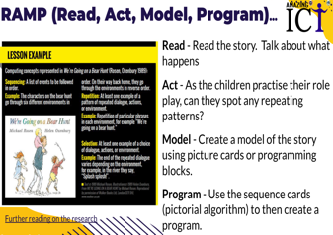  Use of ‘RAMP Model’ ongoing throughout the academic year, linked to various texts.  Nursery Rhymes: https://www.yellow-door.net/products/nursery-rhyme-sequencing-cards/  Traditional Tales: https://www.yellow-door.net/products/tell-me-a-story-sequencing-cards/  Children to use physical coding robots (e.g. Bee-Bots, Blue-Bots etc) to program a physical device. Ongoing throughout the academic year.  Computer Science - Theory  Where opportunities allow, pupils discuss the range of technology used in places such as homes and schools.  Information Technology  Integrate appropriate Purple Mash activities where appropriate linked to the EYFS 2021 Framework:  Online Safety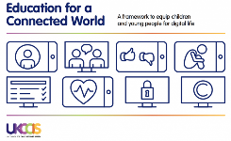  1.Self-Image & Identity  (1 Activity)  https://projectevolve.co.uk/toolkit/resources/years/early-years-7/self-image-and-identity/ | Computer Science – Coding & Computational Thinking  Barefoot Computing - Winter Warmers  https://www.barefootcomputing.org/resources/winter-warmers  RAMP Model  Use of ‘RAMP Model’ ongoing throughout the academic year, linked to various texts.  * Consider purchase of ‘Sequencing Cards' from Yellow Door as a way of introducing pictorial algorithms.  Nursery Rhymes: https://www.yellow-door.net/products/nursery-rhyme-sequencing-cards/  Traditional Tales: https://www.yellow-door.net/products/tell-me-a-story-sequencing-cards/  Children to use physical coding robots (e.g. Bee-Bots, Blue-Bots etc) to program a physical device. Ongoing throughout the academic year.  Computer Science - Theory  Where opportunities allow, pupils discuss the range of technology used in places such as homes and schools.  Information Technology  Integrate appropriate Purple Mash activities where appropriate linked to the EYFS 2021 Framework: https://drive.google.com/file/d/1pmmowo0ZHlFq2XzbTRRKMpjAiDE78h_g/view?usp=sharing  Online Safety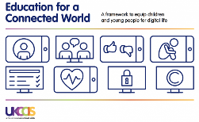  4. Online Bullying  (2 Activities)  * Deliver during Anti-Bullying Week in November  https://projectevolve.co.uk/toolkit/resources/years/early-years-7/online-bullying/  2.Online Relationships  (2 Activities)  https://projectevolve.co.uk/toolkit/resources/years/early-years-7/online-relationships/ | Computer Science – Coding & Computational Thinking  Barefoot Computing - Busy Bodies  https://www.barefootcomputing.org/resources/busy-bodies  RAMP Model  Use of ‘RAMP Model’ ongoing throughout the academic year, linked to various texts.  Nursery Rhymes: https://www.yellow-door.net/products/nursery-rhyme-sequencing-cards/  Traditional Tales: https://www.yellow-door.net/products/tell-me-a-story-sequencing-cards/  Children to use physical coding robots (e.g. Bee-Bots, Blue-Bots etc) to program a physical device. Ongoing throughout the academic year.  Computer Science - Theory  Pupils share their experiences of ‘using’ technology both in and out of school.  Information Technology  Integrate appropriate Purple Mash activities where appropriate linked to the EYFS 2021 Framework:  Online Safety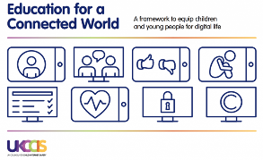  3. Online Reputation  (1 Activity)  * Deliver during the week of Safer Internet Day in February  https://projectevolve.co.uk/toolkit/resources/years/early-years-7/online-reputation/  5. Managing Online Information  (2 Activities)  https://projectevolve.co.uk/toolkit/resources/years/early-years-7/managing-online-information/ | Computer Science – Coding & Computational Thinking  Barefoot Computing – Springtime  https://www.barefootcomputing.org/resources/springtime  RAMP Model  Use of ‘RAMP Model’ ongoing throughout the academic year, linked to various texts.  Nursery Rhymes: https://www.yellow-door.net/products/nursery-rhyme-sequencing-cards/  Traditional Tales: https://www.yellow-door.net/products/tell-me-a-story-sequencing-cards/  Children to use physical coding robots (e.g. Bee-Bots, Blue-Bots etc) to program a physical device. Ongoing throughout the academic year.  Computer Science - Theory  Pupils share their experiences of ‘using’ technology both in and out of school.  Information Technology  Integrate appropriate Purple Mash activities where appropriate linked to the EYFS 2021 Framework:  Online Safety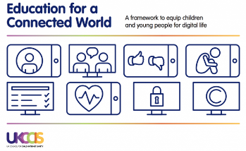  6. Health, Wellbeing & Lifestyle  (2 Activities)  https://projectevolve.co.uk/toolkit/resources/years/early-years-7/health-well-being-and-lifestyle/ | Computer Science – Coding & Computational Thinking  Barefoot Computing - Boats Ahoy  https://www.barefootcomputing.org/resources/boats-ahoy  RAMP Model  Use of ‘RAMP Model’ ongoing throughout the academic year, linked to various texts.  Nursery Rhymes: https://www.yellow-door.net/products/nursery-rhyme-sequencing-cards/  Traditional Tales: https://www.yellow-door.net/products/tell-me-a-story-sequencing-cards/  Children to use physical coding robots (e.g. Bee-Bots, Blue-Bots etc) to program a physical device. Ongoing throughout the academic year.  Computer Science - Theory  Pupils identify the main parts of a computer system (monitor, mouse, keyboard, printer etc).  Information Technology  Integrate appropriate Purple Mash activities where appropriate linked to the EYFS 2021 Framework:  Online Safety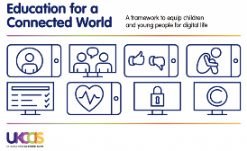  7. Privacy & Security  (2 Activities)  https://projectevolve.co.uk/toolkit/resources/years/early-years-7/privacy-and-security/ | Computer Science – Coding & Computational Thinking  Barefoot Computing - Summer Fun  https://www.barefootcomputing.org/resources/summer-fun  RAMP Model  Nursery Rhymes: https://www.yellow-door.net/products/nursery-rhyme-sequencing-cards/  Traditional Tales: https://www.yellow-door.net/products/tell-me-a-story-sequencing-cards/  Children to use physical coding robots (e.g. Bee-Bots, Blue-Bots etc) to program a physical device. Ongoing throughout the academic year.  Computer Science - Theory  Pupils identify the main parts of a computer system (monitor, mouse, keyboard, printer etc).  Information Technology  Integrate appropriate Purple Mash activities where appropriate linked to the EYFS 2021 Framework:  Online Safety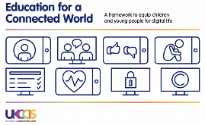  8. Copyright & Ownership  (2 Activities)  https://projectevolve.co.uk/toolkit/resources/years/early-years-7/copyright-and-ownership/
Year 1 | National Curriculum Objectives and Outcomes:  Computer Science – Coding & Computational Thinking  Understand what algorithms are; how they are implemented as programs on digital devices; and that programs execute by following precise and unambiguous instructions.  Y1 - Children understand that an algorithm is a set of instructions used to solve a problem or achieve an objective. They know that a computer program turns an algorithm into code that the computer can understand.  Create and debug simple programs.  Y1 - Children can work out what is wrong with a simple algorithm when the steps are out of order and can write their own simple algorithm. Children know that an unexpected outcome is due to the code they have created and can make logical attempts to fix the code.  Use logical reasoning to predict the behaviour of simple programs.  Y1 - When looking at a program, children can read code one line at a time and make good attempts to envision the bigger picture of the overall effect of the program. Children can, for example, interpret where a Bee-Bot will end up at the end of the program.  Computer Science - Theory  Recognise common uses of information technology beyond school.  Y1 - Children understand what is meant by technology and can identify a variety of examples both in and out of school. They can make a distinction between objects that use modern technology and those that do not e.g. a microwave vs. a chair.  Information Technology  Use technology purposefully to create, organise, store, manipulate and retrieve digital content.  Y1 - Children are able to sort, collate, edit and store simple digital content e.g. children can name, save and retrieve their work and follow simple instructions to access online resources.  Online Safety  Use technology safely and respectfully, keeping personal information private; identify where to go for help and support when they have concerns about content or contact on the internet or other online  Y1- Children understand the importance of keeping information, such as their usernames and passwords, private and actively demonstrate this in lessons. Children take ownership of their work and save this in their own private space such as their My Work folder on Purple Mash.
 | Information Technology  1.1: Exploring Purple Mash  (4 Lessons)  Online Safety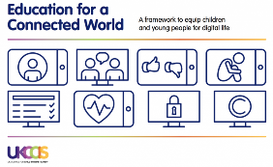  1: Self-Image & Identity  (2 Activities)  https://projectevolve.co.uk/toolkit/resources/years/year-one/self-image-and-identity/  Additional Online Safety Activity  Chicken Clicking - Read the story of ‘Chicken Clicking’ (physical book by Jeanne Willis priced at £6.38).  https://www.amazon.co.uk/Chicken-Clicking-Online-Safety-Picture/dp/1783441615/ref=sr_1_1?keywords=chicken+clicking&qid=1646757795&sprefix=chicken+click%2Caps%2C297&sr=8-1  What personal information did the chick share online? Who did the chick think she was talking too? What did the Fox use to try to trick the chick? | Information Technology  1.3: Pictograms  (3 Lessons)  Allocate Unit 1.3 Quiz (Purple Mash) to all pupils in order to assess knowledge of the unit and skills.  Online Safety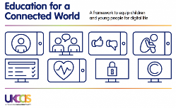  4. Online Bullying  (1 Activity)  * Deliver during Anti-Bullying Week in November  https://projectevolve.co.uk/toolkit/resources/years/year-one/online-bullying/  2. Online Relationships  (4 Activities)  https://projectevolve.co.uk/toolkit/resources/years/year-one/online-relationships/  Additional Online Safety Activity  Hector’s World - Recognising what information would be classed as ‘personal information’ – Hector’s World videos (Details, Details, Details) https://www.youtube.com/watch?v=snbQ3GTXogo | Computer Science – Coding & Computational Thinking  1.5: Maze Explorers  (4 Lessons)  Allocate Unit 1.5 Quiz (Purple Mash) to all pupils in order to assess knowledge of the unit and skills.  Online Safety  3. Online Reputation  (2 Activities)  * Deliver during the week of Safer Internet Day in February  https://projectevolve.co.uk/toolkit/resources/years/year-one/online-reputation/  5. Managing Online Information  (3 Activities)  https://projectevolve.co.uk/toolkit/resources/years/year-one/managing-online-information/ | Information Technology  1.6: Animated Stories  (5 Lessons)  Allocate Unit 1.6 Quiz (Purple Mash) to all pupils in order to assess knowledge of the unit and skills.  Online Safety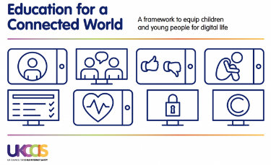  6. Health, Wellbeing & Lifestyle  (1 Activity)  https://projectevolve.co.uk/toolkit/resources/years/year-one/health-well-being-and-lifestyle/  Additional Online Safety Activity  Who’s That Behind the Mask? (foam masks and emojis) Appreciate the impact of their online words. Use of foam masks, statement cards (positive and negative) and emojis. How would someone be feeling (the face behind the mask) if you said . . . ? Use emojis (happy, sad, angry, crying etc emojis) to show how you think your online words would make some feel. | Computer Science – Coding & Computational Thinking  Unplugged Activity – Physical programming. Guide your partner (as if a robot) around a course in the hall, playground or classroom. How can you give precise instructions to your partner (algorithm)? What ways can you debug (find and fix errors) in your algorithm? (e.g. turn around, take 3 steps backwards etc).  Unplugged Activity – Play Hokey Cokey and get children to follow the steps (algorithm). Second time pause and predict what comes next (e.g. after left arm in – do children say left leg, right leg etc . . .both of these would be ‘logical’ answers). Use pictorial algorithm of steps of the Hokey Cokey – character with right arm, left arm etc coloured in. Drop cards and then stick onto hall wall. Are these correct? Get children to sort into the correct order (debugging). Extend to use of ‘instrumental version’ of Hokey Cokey. Get children to choose their own actions (hands on heads etc). They are now creating their own algorithms. How could this be represented in pictures? (pictorial algorithm). At Christmas parties etc look at other ‘guided dances’ (e.g. Cha Cha Slide) where children are following an algorithm.  Hokey Cokey song:  https://www.youtube.com/watch?v=TMCthi3pFEQ  Instrumental version: https://www.youtube.com/watch?v=DFl0xnIdHOc  Online Safety 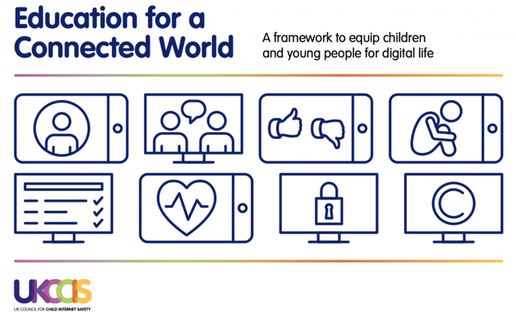  7. Privacy & Security  (3 Activities)  https://projectevolve.co.uk/toolkit/resources/years/year-one/privacy-and-security/  Additional Online Safety Activity  Smartie the Penguin - Explain why it is important to communicate safely and respectfully online.  Read ‘Adventures of Smartie the Penguin’ https://www.childnet.com/resources/smartie-the-penguin and discuss the different scenarios that Smartie finds himself in. What decisions should he make? | Computer Science – Theory  1.9: Technology Outside of School  (2 Lessons)  Allocate Unit 1.9 Quiz (Purple Mash) to all pupils in order to assess knowledge of the unit and skills.  Use NCCE Teach Computing ‘Technology Around Us’ unit https://teachcomputing.org/curriculum/key-stage-1/computing-systems-and-networks-technology-around-us as a stimulus for exploring the different technology in our lives at school and at home.  Online Safety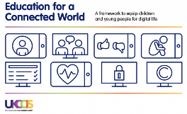  8. Copyright & Ownership  (4 Activities)  https://projectevolve.co.uk/toolkit/resources/years/year-one/copyright-and-ownership/  Additional Online Safety Activity  Show 'Lee and Kim' CEOP video: https://drive.google.com/file/d/1b4CZb6362fFyESwfuVgj_81CIip8qHK9/view?usp=sharing  Learn Captain Syd's song about how to stay safe online.  Use masks to identify who was playing the part of the different animals in the game. Were they nice or nasty? Refer to Captain Syd’s tips for how to stay safe online.  Link to access masks: https://drive.google.com/drive/folders/1XpdFjA_8WkDs1SBx3UzVXwa-vrqmWc8-?usp=sharing
Year 2 | National Curricuulum Objectives and Outcomes:  Computer Science – Coding & Computational Thinking  Understand what algorithms are; how they are implemented as programs on digital devices; and that programs execute by following precise and unambiguous instructions.  Y2 - Children can explain that an algorithm is a set of instructions to complete a task. When designing simple programs, children show an awareness of the need to be precise with their algorithms so that they can be successfully converted into code.  Create and debug simple programs.  Y2 - Children can create a simple program that achieves a specific purpose. They can also identify and correct some errors. Children’s program designs display a growing awareness of the need for logical, programmable steps.  Use logical reasoning to predict the behaviour of simple programs.  Y2 - Children can identify the parts of a program that respond to specific events and initiate specific actions. For example, they can write a cause and effect sentence of what will happen in a program.  Computer Science - Theory  Recognise common uses of information technology beyond school.  Y2 - Children can effectively retrieve relevant, purposeful digital content using a search engine. They can apply their learning of effective searching beyond the classroom and can share this knowledge. Children make links between technology they see around them, coding and multimedia work they do in school e.g. animations, interactive code and programs.  Information Technology  Use technology purposefully to create, organise, store, manipulate and retrieve digital content.  Y2 - Children demonstrate an ability to organise data using, for example, a database and can retrieve specific data for conducting simple searches. Children are able to edit more complex digital data such as music compositions. Children are confident when creating, naming, saving and retrieving content. Children use a range of media in their digital content including photos, text and sound.  Online Safety  Use technology safely and respectfully, keeping personal information private; identify where to go for help and support when they have concerns about content or contact on the internet or other online  Y2 - Children know the implications of inappropriate online searches. Children begin to understand how things are shared electronically such as posting work to school social media accounts. They develop an understanding of communicating safely online (e.g. using email safely by using 2Respond activities on Purple Mash) and know ways of reporting inappropriate behaviours and content.
 | Information Technology  2.6: Creating Pictures (5 Lessons)  Allocate Unit 2.6 Quiz (Purple Mash) to all pupils in order to assess knowledge of the unit and skills.  Online Safety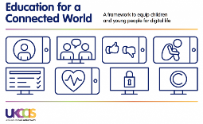  1.Self-Image & Identity  (2 Activities)  https://projectevolve.co.uk/toolkit/resources/years/year-one/self-image-and-identity/ |  | Computer Science – Coding & Computational Thinking  2.1: Coding - Crash Course (6 Lessons)  Allocate Unit 2.1 Quiz (Purple Mash) to all pupils in order to assess knowledge of the unit and skills.  Online Safety  3. Online Reputation  (3 Activities)  * Deliver during the week of Safer Internet Day in February  https://projectevolve.co.uk/toolkit/resources/years/year-one/online-reputation/  5. Managing Online Information  (5 Activities)  https://projectevolve.co.uk/toolkit/resources/years/year-one/managing-online-information/  Additional Online Safety Activity  Online Safety in Fairy Tales - link to texts (e.g. Cinderella, Little Red Riding Hood). Identify information that character should and should not share online if they were placing and advert for ‘owner of shoe’ etc. | Information Technology  2.3: Spreadsheets (4 Lessons)  Allocate Unit 2.3Quiz (Purple Mash) to all pupils in order to assess knowledge of the unit and skills.  Online Safety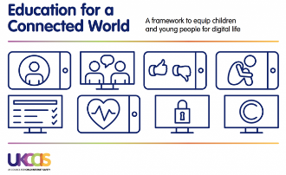  6. Health, Wellbeing & Lifestyle  (2 Activities)  https://projectevolve.co.uk/toolkit/resources/years/year-one/health-well-being-and-lifestyle/  . | Computer Science – Theory  Use NCCE Teach Computing ‘IT Around Us’ unit (lessons 1-4) https://teachcomputing.org/curriculum/key-stage-1/computing-systems-and-networks-it-around-us as a stimulus for exploring how information technology is being used for good in our lives.  Unplugged Activity – iWristband. Discuss ‘Wearable Technology’ as ‘common us of use of ICT beyond school’. What examples do the children know? (adults in their lives will have Apple Watches, FitBits etc – teachers may also have examples they can demonstrate). Explain that the task for the pupils is to design their own ‘iWristband’. What features would your watch contain? Using carboard strap and paper-folder concertina book pupils make a watch with icons to demonstrate the different features of their iWatch. Showcase your watches to the class at the end of the lesson and discuss feedback.  Lesson slides: https://drive.google.com/drive/folders/17iBYccf0Pgh97IooAS9-7KCxYXCP_2__?usp=sharing  Computer Science – Coding & Computational Thinking  Children to use physical coding robots (e.g. Bee-Bots, Blue-Bots etc) to program a physical device to achieve a given goal. This could be linked to a current topic/book (e.g. Little Red Riding Hood visiting grandma’s house). Progression in skills from when physical programming robots were used in Year 1.  Unplugged Activity: ‘Monster Hop’ (could also be linked to Dinosaurs, Aliens etc). Make a physical track for pupils to follow an algorithm (different footprints in different directions). These can either be made of paper/card or could be drawn onto the playground in chalk etc.  Link to example video: https://drive.google.com/drive/folders/17soBjUAiq17uBrLWpdlEo9EoTB12_kTR?usp=sharing  Computer Science – Coding & Computational Thinking  Create a ‘Getting Up’ (what do you do from getting out of bed until you leave the house to come to school?) Algorithm flowchart. Focus on the ‘precise’ nature of steps (for example you do not just ‘get out of bed and have your breakfast’ – there are many steps to this. Use ‘2Chart’ (Purple Mash) to create your flowchart.  Online Safety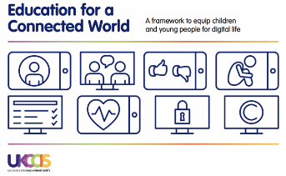  7. Privacy & Security  (4 Activities)  https://projectevolve.co.uk/toolkit/resources/years/year-one/privacy-and-security/ | Information Technology  2.4: Questioning (5 Lessons)  Allocate Unit 2.4 Quiz (Purple Mash) to all pupils in order to assess knowledge of the unit and skills.  Online Safety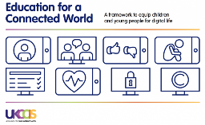  8. Copyright & Ownership  (2 Activities)  https://projectevolve.co.uk/toolkit/resources/years/year-one/copyright-and-ownership/
Year 3 | National Curricuulum Objectives and Outcomes:  Computer Science – Coding & Computational Thinking  Design, write and debug programs that accomplish specific goals, including controlling or simulating physical systems; solve problems by decomposing them into smaller parts.  Y3 - Children can turn a simple real-life situation into an algorithm for a program by deconstructing it into manageable parts. Their design shows that they are thinking of the desired task and how this translates into code. Children can identify an error within their program that prevents it following the desired algorithm and then fix it.  Use sequence, selection and repetition in programs; work with variables and various forms of input and output.  Y3 - Children demonstrate the ability to design and code a program that follows a simple sequence. They experiment with timers to achieve repetition effects in their programs. Children are beginning to understand the difference in the effect of using a timer command rather than a repeat command when creating repetition effects. Children understand how variables can be used to store information while a program is executing.  Use logical reasoning to explain how some simple algorithms work and to detect and correct errors in algorithms and programs.  Y3 - Children’s designs for their programs show that they are thinking of the structure of a program in logical, achievable steps and absorbing some new knowledge of coding structures. For example, ‘if’ statements, repetition and variables. They make good attempts to ‘step through’ more complex code in order to identify errors in algorithms and can correct this. In programs they can ‘read’ programs with several steps and predict the outcome accurately.  Computer Science - Theory  Understand computer networks, including the internet; how they can provide multiple services, such as the World Wide Web, and the opportunities they offer for communication and collaboration.  Y3 - Children can list a range of ways that the internet can be used to provide different methods of communication. They can use some of these methods of communication, e.g. being able to open, respond to and attach files to emails. They can describe appropriate email conventions when communicating in this way.  Information Technology  Select, use and combine a variety of software (including internet services) on a range of digital devices to design and create a range of programs, systems and content that accomplish given goals, including collecting, analysing, evaluating and presenting data and information.  Y3 - Children can collect, analyse, evaluate and present data and information using a selection of software, e.g. using a branching database (2Question), using software such as 2Graph. Children can consider what software is most appropriate for a given task. They can create purposeful content to attach to emails.  Online Safety  Use technology safely, respectfully and responsibly; recognise acceptable/ unacceptable behaviour; identify a range of ways to report concern about content and contact.  Y3 - Children demonstrate the importance of having a secure password and not sharing this with anyone else. Furthermore, children can explain the negative implications of failure to keep passwords safe and secure. They understand the importance of staying safe and the importance of their conduct when using familiar communication tools. They know more than one way to report unacceptable content and contact.  Use search technologies effectively, appreciate how results are selected and ranked, and be discerning in evaluating digital content.  Y3 - Children can carry out simple searches to retrieve digital content. They understand that to do this, they are connecting to the internet and using a search engine such as Purple Mash search or internet-wide search engines.
 | Information Technology  3.3: Spreadsheets  (3 Lessons)  Allocate Unit 3.3 Quiz (Purple Mash) to all pupils in order to assess knowledge of the unit and skills.  3.8: Graphing  (2 Lessons)  Allocate Unit 3.8 Quiz (Purple Mash) to all pupils in order to assess knowledge of the unit and skills.  Online Safety  1.Self-Image & Identity  (2 Activities)  https://projectevolve.co.uk/toolkit/resources/years/year-three/self-image-and-identity/  Additional Online Safety Activity  Play, Like, Share - ‘Play, Like, Share’ (CEOP Video) – Episode 1 (link to sites/apps like YouTube and TikTok that children are regularly using) https://www.youtube.com/watch?v=WpngtGyc_ec&t=193s |  | Information Technology  3.5: Email  (6 Lessons)  Allocate Unit 3.5 Quiz (Purple Mash) to all pupils in order to assess knowledge of the unit and skills.  Online Safety  3. Online Reputation  (3 Activities)  * Deliver during the week of Safer Internet Day in February  https://projectevolve.co.uk/toolkit/resources/years/year-three/online-reputation/  5. Managing Online Information  (5 Activities)  https://projectevolve.co.uk/toolkit/resources/years/year-three/managing-online-information/  Additional Online Safety Activity  Tek the Modern Cave Boy - Read the story of ‘Tek – The Modern Cave Boy’ by Patrick McDonnell. https://www.amazon.co.uk/Tek-Modern-Cave-Patrick-McDonnell/dp/0316338052/ref=sr_1_1?keywords=tek+the+modern+cave+boy&qid=1656583610&sprefix=Tek+the+m%2Caps%2C165&sr=8-1 | Information Technology  3.6: Branching Databases  (4 Lessons)  Allocate Unit 3.6 Quiz (Purple Mash) to all pupils in order to assess knowledge of the unit and skills.  Online Safety 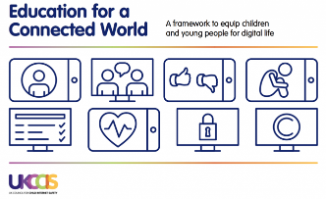  6. Health, Wellbeing & Lifestyle  (2 Activities)  https://projectevolve.co.uk/toolkit/resources/years/year-three/health-well-being-and-lifestyle/  Additional Online Safety Activity  Play, Like Share- Show ‘Play Like Share’ CEOP Video – Episode 2. https://www.youtube.com/watch?v=NscU1ZHYPDk&t=7s  Create a page (fictitious person, maybe a superhero or character from class novel etc) for a social media website (Facebook style).  What information would you include? What information should you not display? Why do you think that websites such as Facebook etc have an age limit of 13? Think about the layout and design of the page, combining images, text and other media in a visually effective way.  Facebook Template: https://docs.google.com/document/d/1ZAKNkc4hPjIHdYRvu1ywIIIszP_bJXUf/edit?usp=sharing&ouid=115688390933151199123&rtpof=true&sd=true | Computer Science – Coding & Computational Thinking  3.1: Coding  (6 Lessons)  Allocate Unit 3.1 Quiz (Purple Mash) to all pupils in order to assess knowledge of the unit and skills.  Online Safety 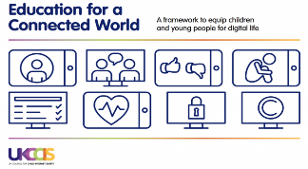  7. Privacy & Security  (4 Activities)  https://projectevolve.co.uk/toolkit/resources/years/year-three/privacy-and-security/  Additional Online Safety Activity  Hidden Extras - Look at range of website offering holidays to a worldwide detination. How do you know that a website is genuine? Discuss ‘hidden extras’ (suitcase allowance etc) with different travel companies and the ‘true cost’ of a holiday? | Information Technology  3.9: Presenting – PowerPoint/Slides  (4 Lessons)  Allocate Unit 3.9 Quiz (Purple Mash) to all pupils in order to assess knowledge of the unit and skills.  Computer Science – Coding & Computational Thinking  Unplugged Activity: ‘Sandwich Bot’. Children to create an algorithm using precise and unambiguous instructions in order to get their teacher (‘Sandwich Bot 3000’) to make a jam sandwich. https://drive.google.com/drive/folders/1Jls0t6vlOG5URo2vTUJE783uLIkrk_DB?usp=sharing  Videos of Phil Bagge as ‘Sandwich Bot’: https://www.youtube.com/watch?v=VFUs3GvMSVc  https://www.youtube.com/watch?v=leBEFaVHllE  Online Safety 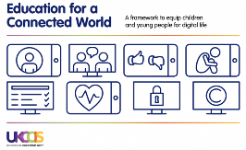  8. Copyright & Ownership  (2 Activities)  https://projectevolve.co.uk/toolkit/resources/years/year-three/copyright-and-ownership/
Year 4 | National Curricuulum Objectives and Outcomes:  Computer Science – Coding & Computational Thinking  Design, write and debug programs that accomplish specific goals, including controlling or simulating physical systems; solve problems by decomposing them into smaller parts.  Y4 - When turning a real-life situation into an algorithm, the children’s design shows that they are thinking of the required task and how to accomplish this in code using coding structures for selection and repetition. Children make more intuitive attempts to debug their own programs.  Use sequence, selection and repetition in programs; work with variables and various forms of input and output.  Y4 - Children’s use of timers to achieve repetition effects are becoming more logical and are integrated into their program designs. They understand ‘if statements’ for selection and attempt to combine these with other coding structures including variables to achieve the effects that they design in their programs. As well as understanding how variables can be used to store information while a program is executing, they are able to use and manipulate the value of variables. Children can make use of user inputs and outputs such as ‘print to screen’. e.g. 2Code.  Use logical reasoning to explain how some simple algorithms work and to detect and correct errors in algorithms and programs.  Y4 - Children’s designs for their programs show that they are thinking of the structure of a program in logical, achievable steps and absorbing some new knowledge of coding structures. For example, ‘if’ statements, repetition and variables. They can trace code and use step through methods to identify errors in code and make logical attempts to correct this. e.g. traffic light algorithm in 2Code. In programs such as Logo, they can ‘read’ programs with several steps and predict the outcome accurately.  Computer Science - Theory  Understand computer networks, including the internet; how they can provide multiple services, such as the World Wide Web, and the opportunities they offer for communication and collaboration.  Y4 - Children recognise the main component parts of hardware which allow computers to join and form a network. Their ability to understand the online safety implications associated with the ways the internet can be used to provide different methods of communication is improving.  Information Technology  Select, use and combine a variety of software (including internet services) on a range of digital devices to design and create a range of programs, systems and content that accomplish given goals, including collecting, analysing, evaluating and presenting data and information.  Y4 - Children are able to make improvements to digital solutions based on feedback. Children make informed software choices when presenting information and data. They create linked content using a range of software. Children share digital content within their community via a variety of methods.  Online Safety  Use technology safely, respectfully and responsibly; recognise acceptable/ unacceptable behaviour; identify a range of ways to report concern about content and contact.  Y4 - Children can explore key concepts relating to online safety and can help others to understand the importance of online safety. Children know a range of ways of reporting inappropriate content and contact.  Use search technologies effectively, appreciate how results are selected and ranked, and be discerning in evaluating digital content.  Y4 - Children understand the function, features and layout of a search engine. They can appraise selected webpages for credibility and information at a basic level.
 | Information Technology  4.4: Writing for Different Audiences  (5 Lessons)  Allocate Unit 4.4 Quiz (Purple Mash) to all pupils in order to assess knowledge of the unit and skills.  Computer Science – Coding & Computational Thinking  A.L.E.X. app.  Use logical reasoning to explain how some simple algorithms work and to detect and correct errors in algorithms and programs.  Children’s designs for their programs show that they are thinking of the structure of a program in logical, achievable steps and absorbing some new knowledge of coding structures. They can trace code and use step through methods to identify errors in code and make logical attempts to correct this.  https://apps.apple.com/gb/app/a-l-e-x/id597040772  * Consider purchase of ‘Let’s Go Code Activity’ set so as to combine the plugged with the unplugged activity through use of the floor mats. https://www.amazon.co.uk/Learning-Resources-Lets-Code-Activity/dp/B01N7MMCMO  Online Safety  1.Self-Image & Identity  (2 Activities)  https://projectevolve.co.uk/toolkit/resources/years/4/self-image-and-identity/ | Computer Science – Coding & Computational Thinking  4.5: Logo  (4  Allocate Unit 4.5 Quiz (Purple Mash) to all pupils in order to assess knowledge of the unit and skills.  Green Screen by Do:Ink app to make a TV programme linked to current topic.  https://apps.apple.com/gb/app/green-screen-by-do-ink/id730091131  Select, use and combine a variety of software (including internet services) on a range of digital devices to design and create a range of programs, systems and content that accomplish given goals, including collecting, analysing, evaluating and presenting data and information.  Children are able to make improvements to digital solutions based on feedback. Children make informed software choices when presenting information and data. They create linked content using a range of software. Children share digital content within their community via a variety of methods.  Online Safety  4. Online Bullying  (3 Activities)  * Deliver during Anti-Bullying Week in November  https://projectevolve.co.uk/toolkit/resources/years/4/online-bullying/  2. Online Relationships  (7 Activities)  https://projectevolve.co.uk/toolkit/resources/years/4/online-relationships/ | Computer Science – Coding & Computational Thinking  4.1: Coding  (6 Lessons)  Allocate Unit 4.1 Quiz (Purple Mash) to all pupils in order to assess knowledge of the unit and skills.  Information Technology  Clips app to demonstrate knowledge and understanding of current topic by making a presentation. Share with wider audience via school Twitter account.  Select, use and combine a variety of software (including internet services) on a range of digital devices to design and create a range of programs, systems and content that accomplish given goals, including collecting, analysing, evaluating and presenting data and information.  Children are able to make improvements to digital solutions based on feedback. Children make informed software choices when presenting information and data. They create linked content using a range of software. Children share digital content within their community via a variety of methods.  Online Safety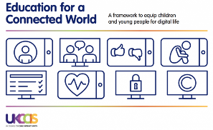  3. Online Reputation  (3 Activities)  * Deliver during the week of Safer Internet Day in February  https://projectevolve.co.uk/toolkit/resources/years/4/online-reputation/  5. Managing Online Information  (5 Activities)  https://projectevolve.co.uk/toolkit/resources/years/4/managing-online-information/ | Information Technology  4.6: Animation  (3 Lessons)  Allocate Unit 4.6 Quiz (Purple Mash) to all pupils in order to assess knowledge of the unit and skills.  Online Safety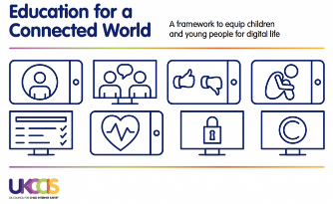  6. Health, Wellbeing & Lifestyle  (2 Activities)  https://projectevolve.co.uk/toolkit/resources/years/4/health-well-being-and-lifestyle/ | Information Technology  4.9: Making Music  (4 Lessons)  Allocate Unit 4.9 Quiz (Purple Mash) to all pupils in order to assess knowledge of the unit and skills.  Computer Science – Coding & Computational Thinking  Unplugged Activity – ‘Dot Draw Code’. Children to create their own design and then produce the code as to how someone else would make their image.  https://drive.google.com/drive/folders/1YTS5LX1Ydz6qdRNI2ecC9NhCisUm0gXp?usp=sharing  Design, write and debug programs that accomplish specific goals, including controlling or simulating physical systems; solve problems by decomposing them into smaller parts.  When turning a real-life situation into an algorithm, the children’s design shows that they are thinking of the required task and how to accomplish this in code. Children make more intuitive attempts to debug their own programs.  Online Safety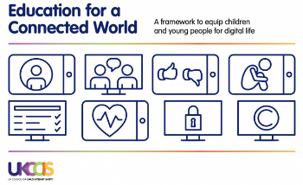  7. Privacy & Security  (4 Activities)  https://projectevolve.co.uk/toolkit/resources/years/4/privacy-and-security/  Additional Online Safety Activity  Troll Stinks - Read the story ‘Troll Stinks’ by Jeanne Willis. https://www.amazon.co.uk/Troll-Stinks-Online-Safety-Picture/dp/1783445696/ref=sr_1_2?crid=2VDCV7KSH0SKX&keywords=troll+stinks&qid=1656584509&sprefix=troll+stinks+%2Caps%2C77&sr=8-2 Discuss the impact that our online words have on people (online life is ‘real life’, the things that we do and say online have just as much impact on people as what they do when we say things face-to-face). Have a list of statement cards and pupils to have different emojis (happy, sad, angry, crying etc). Use emojis to indicate how the person at the other end of the screen would be feeling if you had said/done the action on the statement card.  Troll Stinks Read Aloud Video (YouTube): https://www.youtube.com/watch?v=nIG9RPQEEz4
Year 5 | National Curricuulum Objectives and Outcomes:  Computer Science – Coding & Computational Thinking  Design, write and debug programs that accomplish specific goals, including controlling or simulating physical systems; solve problems by decomposing them into smaller parts.  Y5 - Children may attempt to turn more complex real-life situations into algorithms for a program by deconstructing it into manageable parts. Children are able to test and debug their programs as they go and can use logical methods to identify the approximate cause of any bug but may need some support identifying the specific line of code.  Use sequence, selection and repetition in programs; work with variables and various forms of input and output.  Y5 - Children can translate algorithms that include sequence, selection and repetition into code with increasing ease and their own designs show that they are thinking of how to accomplish the set task in code utilising such structures. They are combining sequence, selection and repetition with other coding structures to achieve their algorithm design.  Use logical reasoning to explain how some simple algorithms work and to detect and correct errors in algorithms and programs.  Y5 - When children code, they are beginning to think about their code structure in terms of the ability to debug and interpret the code later, e.g. the use of tabs to organise code and the naming of variables.  Computer Science - Theory  Understand computer networks, including the internet; how they can provide multiple services, such as the World Wide Web, and the opportunities they offer for communication and collaboration.  Y5 - Children understand the value of computer networks but are also aware of the main dangers. They recognise what personal information is and can explain how this can be kept safe. Children can select the most appropriate form of online communications contingent on audience and digital content.  Information Technology  Select, use and combine a variety of software (including internet services) on a range of digital devices to design and create a range of programs, systems and content that accomplish given goals, including collecting, analysing, evaluating and presenting data and information.  Y5 - Children are able to make appropriate improvements to digital solutions based on feedback received and can confidently comment on the success of the solution. They objectively review solutions from others. Children are able to collaboratively create content and solutions using digital features within software such as collaborative mode. They are able to use several ways of sharing digital content.  Online Safety  Use technology safely, respectfully and responsibly; recognise acceptable/ unacceptable behaviour; identify a range of ways to report concern about content and contact.  Y5 - Children have a secure knowledge of common online safety rules and can apply this by demonstrating the safe and respectful use of a few different technologies and online services. Children implicitly relate appropriate online behaviour to their right to personal privacy and mental wellbeing of themselves and others.  Use search technologies effectively, appreciate how results are selected and ranked, and be discerning in evaluating digital content.  Y5 - Children search with greater complexity for digital content when using a search engine. They are able to explain in some detail how credible a webpage is and the information it contains.
 | Information Technology  5.4: Databases  (4 Lessons)  Allocate Unit 5.4 Quiz (Purple Mash) to all pupils in order to assess knowledge of the unit and skills.  Computer Science – Coding & Computational Thinking  Lightbot Code Hour app:  Use sequence, selection and repetition in programs; work with variables and various forms of input and output.  Children can translate algorithms that include sequence, selection and repetition into code with increasing ease and their own designs show that they are thinking of how to accomplish the set task in code utilising such structures. They are combining sequence, selection and repetition with other coding structures to achieve their algorithm design.  https://apps.apple.com/us/app/lightbot-code-hour/id873943739  Online Safety  1.Self-Image & Identity  (3 Activities)  https://projectevolve.co.uk/toolkit/resources/years/5/self-image-and-identity/ | Information Technology  5.5 Game Creator  (5 Lessons)  Allocate Unit 5.5 Quiz (Purple Mash) to all pupils in order to assess knowledge of the unit and skills.  Computer Science – Coding & Computational Thinking  Unplugged Activity: Flanimals / Crazy Characters. Use the book ‘Flanimals’ by Ricky Gervais. Each pupil to be given image of a ‘Flanimal’. Sit back-to-back with partner and describe using ‘precise’ language how to draw your Flanimal. Pupils then create their own ‘Flanimal' and create a precise step-by-step set of instructions as to how someone else would draw this.  * This lesson is based on the Barefoot Computing ‘Crazy Characters’ lesson: https://www.barefootcomputing.org/resources/crazy-character-algorithms  Flanimals Book: https://www.amazon.co.uk/Flanimals-Ricky-Gervais/dp/0571220770/ref=tmm_hrd_swatch_0?_encoding=UTF8&qid=&sr=  Online Safety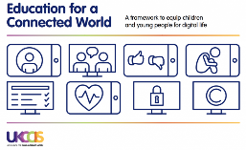  4. Online Bullying  (3 Activities)  * Deliver during Anti-Bullying Week in November  https://projectevolve.co.uk/toolkit/resources/years/5/online-bullying/  2.Online Relationships  (3 Activities)  https://projectevolve.co.uk/toolkit/resources/years/5/online-relationships/ | Computer Science – Coding & Computational Thinking  5.1: Coding  (6 Lessons)  Allocate Unit 5.1 Quiz (Purple Mash) to all pupils in order to assess knowledge of the unit and skills.  Online Safety 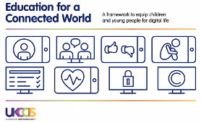  3. Online Reputation  (2 Activities)  * Deliver during the week of Safer Internet Day in February  https://projectevolve.co.uk/toolkit/resources/years/5/online-reputation/  5. Managing Online Information  (6 Activities)  https://projectevolve.co.uk/toolkit/resources/years/5/managing-online-information/ | Information Technology  5.8: Word Processing – Word/Google Docs  (8 Lessons: Lessons 1-4)  Computer Science – Coding & Computational Thinking  Scratch – ‘Scratch Coding Cards’ (‘Pong Game’). https://www.amazon.co.uk/Scratch-Coding-Cards-Natalie-Rusk/dp/1593279760/ref=asc_df_1593279760/?tag=googshopuk-21&linkCode=df0&hvadid=240910969091&hvpos=&hvnetw=g&hvrand=10156897798194215999&hvpone=&hvptwo=&hvqmt=&hvdev=c&hvdvcmdl=&hvlocint=&hvlocphy=1006736&hvtargid=pla-650434061007&psc=1&th=1&psc=1  Online Safety 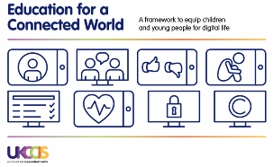  6. Health, Wellbeing & Lifestyle  (2 Activities)  https://projectevolve.co.uk/toolkit/resources/years/5/health-well-being-and-lifestyle/ | Computer Science – Theory  Use NCCE Teach Computing ‘Sharing Information’ unit (lessons 1-3) https://teachcomputing.org/curriculum/key-stage-2/computing-systems-and-networks-sharing-information In this unit, learners will develop their understanding of computer systems and how information is transferred between systems and devices. Learners will consider small-scale systems as well as large-scale systems. They will explain the input, output, and process aspects of a variety of different real-world systems.  Information Technology  5.8: Word Processing – Word/Pages  (8 Lessons: Lessons 5-8)  Allocate Unit 5.8 Quiz (Purple Mash) to all pupils in order to assess knowledge of the unit and skills.  Online Safety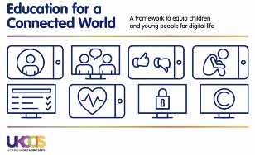  7. Privacy & Security  (4 Activities)  https://projectevolve.co.uk/toolkit/resources/years/5/privacy-and-security/  Additional Online Safety Activity  'Tree Octopus' website www.zapatopi.net/treeoctopus  Children carry out series of comprehension type questions based on website content (do not tell them that website is fake at this stage!!!) End lesson by asking children to evaluate what they read and researched . . . . then reveal that website is FAKE!!!!! (there is no such thing as a Tree Octopus) We cannot always trust what we read and see online!  Tree Octopus Comprehension: https://drive.google.com/file/d/1nhjlyZIoentUTJIhk6IHWoABR1xeDxpl/view?usp=sharing | Information Technology  5.6: 3D Modelling  (4 Lessons)  Allocate Unit 5.6 Quiz (Purple Mash) to all pupils in order to assess knowledge of the unit and skills.  Computer Science – Coding & Computational Thinking  Unplugged Activity –  Create an unambiguous and precise step-by-step set of instructions linked to a current topic. This could for example be how to play the Mayan game of ‘Pok-a-Tok’ or how an Egyptian slave would build a pyramid.  Online Safety 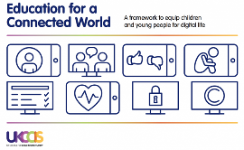  8. Copyright & Ownership  (2 Activities)  https://projectevolve.co.uk/toolkit/resources/years/5/copyright-and-ownership/
Year 6 | National Curricuulum Objectives and Outcomes:  Computer Science – Coding & Computational Thinking  Design, write and debug programs that accomplish specific goals, including controlling or simulating physical systems; solve problems by decomposing them into smaller parts.  Y6 - Children are able to turn a more complex programming task into an algorithm by identifying the important aspects of the task (abstraction) and then decomposing them in a logical way using their knowledge of possible coding structures and applying skills from previous programs. Children test and debug their program as they go and use logical methods to identify the cause of bugs, demonstrating a systematic approach to try to identify a particular line of code causing a problem.  Use sequence, selection and repetition in programs; work with variables and various forms of input and output.  Y6 - Children translate algorithms that include sequence, selection and repetition into code and their own designs show that they are thinking of how to accomplish the set task in code utilising such structures, including nesting structures within each other. Coding displays an improving understanding of variables in coding, outputs such as sound and movement, inputs from the user of the program such as button clicks and the value of functions.  Use logical reasoning to explain how some simple algorithms work and to detect and correct errors in algorithms and programs.  Y6 - Children are able to interpret a program in parts and can make logical attempts to put the separate parts of a complex algorithm together to explain the program as a whole.  Computer Science - Theory  Understand computer networks, including the internet; how they can provide multiple services, such as the World Wide Web, and the opportunities they offer for communication and collaboration.  Y6 - Children understand and can explain in some depth the difference between the internet and the World Wide Web. Children know what a WAN and LAN are and can describe how they access the internet in school.  Information Technology  Select, use and combine a variety of software (including internet services) on a range of digital devices to design and create a range of programs, systems and content that accomplish given goals, including collecting, analysing, evaluating and presenting data and information.  Y6 - Children make clear connections to the audience when designing and creating digital content. The children design and create their own blogs to become a content creator on the internet, e.g. 2Blog. They are able to use criteria to evaluate the quality of digital solutions and are able to identify improvements, making some refinements.  Online Safety  Use technology safely, respectfully and responsibly; recognise acceptable/ unacceptable behaviour; identify a range of ways to report concern about content and contact.  Y6 - Children demonstrate the safe and respectful use of a range of different technologies and online services. They identify more discreet inappropriate behaviours through developing critical thinking, e.g. 2Respond activities. They recognise the value in preserving their privacy when online for their own and other people’s safety  Use search technologies effectively, appreciate how results are selected and ranked, and be discerning in evaluating digital content.  Y6 - Children readily apply filters when searching for digital content. They are able to explain in detail how credible a webpage is and the information it contains. They compare a range of digital content sources and are able to rate them in terms of content quality and accuracy. Children use critical thinking skills in everyday use of online communication.
 | Information Technology  6.4 Blogging  (4 Lessons)  Allocate Unit 6.4 Quiz (Purple Mash) to all pupils in order to assess knowledge of the unit and skills.  Computer Science – Coding & Computational Thinking  Scratch website: https://scratch.mit.edu/  Design, write and debug programs that accomplish specific goals, including controlling or simulating physical systems; solve problems by decomposing them into smaller parts.  Children are able to turn a more complex programming task into an algorithm by identifying the important aspects of the task (abstraction) and then decomposing them in a logical way using their knowledge of possible coding structures and applying skills from previous programs. Children test and debug their program as they go and use logical methods to identify the cause of bugs, demonstrating a systematic approach to try to identify a particular line of code causing a problem.  Online Safety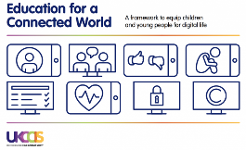  1.Self-Image & Identity  (3 Activities)  https://projectevolve.co.uk/toolkit/resources/years/6/self-image-and-identity/  Additional Online Safety Activity  'I've seen Alex's Willy' video from NSPCC https://www.facebook.com/nspcc/videos/i-saw-your-willy/10157849113309852/  Message of ‘Be Share Aware’. Follow into ‘Grandma Rule’. Follow this up by 'Talking PANTS' with the pupils:  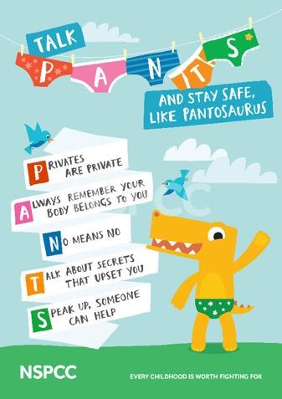 | Information Technology  6.9: Spreadsheets – Excel or Sheets  (8 Lessons: Lessons 1-4)  Computer Science – Coding & Computational Thinking  Spritebox Code Hour app:  Use logical reasoning to explain how some simple algorithms work and to detect and correct errors in algorithms and programs.  Children are able to interpret a program in parts and can make logical attempts to put the separate parts of a complex algorithm together to explain the program as a whole.  https://apps.apple.com/us/app/spritebox-code-hour/id1161515477  Online Safety  4. Online Bullying  (2 Activities)  * Deliver during Anti-Bullying Week in November  https://projectevolve.co.uk/toolkit/resources/years/6/online-bullying/  2.Online Relationships  (4 Activities)  https://projectevolve.co.uk/toolkit/resources/years/6/online-relationships/  Additional Online Safety Activity  Read the story ‘The Technology Tail’ by Julia Cook. Compare this to own online lives. Create a class breakdown of ‘online life’. What are the popular apps, sites etc that are used? Does language, behaviour etc in these mirror that within school and within the classroom? Discuss WhatsApp groups and other popular ways of communicating as a group outside of school. Is the administrator of the group fair? Do they ‘police’ the group well? Would you be happy for your parent, teacher etc to see and read the things that are shared in the group? If you wouldn’t say it in the classroom, then you shouldn’t say it online. Create ‘Class Conduct’ for use of popular apps such as WhatsApp, Instagram, Snapchat etc and for popular games such as Fortnite where conversation is possible. Share these on class display, within communal areas within school etc. | Computer Science – Coding & Computational Thinking  6.1: Coding  (6 Lessons)  Information Technology  Garageband app - Make musical composition linked to current topic.  Select, use and combine a variety of software (including internet services) on a range of digital devices to design and create a range of programs, systems and content that accomplish given goals, including collecting, analysing, evaluating and presenting data and information.  Children make clear connections to the audience when designing and creating digital content. They are able to use criteria to evaluate the quality of digital solutions and are able to identify improvements, making some refinements.  Online Safety 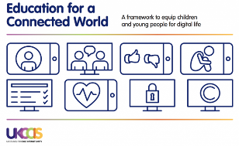  3. Online Reputation  (2 Activities)  * Deliver during the week of Safer Internet Day in February  https://projectevolve.co.uk/toolkit/resources/years/6/online-reputation/  5. Managing Online Information  (11 Activities)  https://projectevolve.co.uk/toolkit/resources/years/6/managing-online-information/  Additional Online Safety Activity  Trying same search on different search engines (e.g. Edge, Google Chrome, Bing, Yahoo etc). Do they all return the results? What might the reason for the difference? (companies pay to have their results ranked higher) | Computer Science – Theory  Use NCCE Teach Computing ‘Communication’ unit (lessons 1-6) https://teachcomputing.org/curriculum/key-stage-2/computing-systems-and-networks-communication In this unit, the class will learn about the World Wide Web as a communication tool. First, they will learn how we find information on the World Wide Web, through learning how search engines work (including how they select and rank results) and what influences searching, and through comparing different search engines. They will then investigate different methods of communication, before focusing on internet-based communication. Finally, they will evaluate which methods of internet communication to use for particular purposes.  6.8 Binary  (4 Lessons)  Allocate Unit 6.8 Quiz (Purple Mash) to all pupils in order to assess knowledge of the unit and skills.  Online Safety 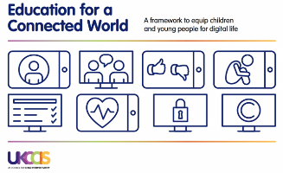  6. Health, Wellbeing & Lifestyle  (4 Activities)  https://projectevolve.co.uk/toolkit/resources/years/6/health-well-being-and-lifestyle/  Additional Online Safety Activity  Play, Like, Share’ (CEOP Video) – Episode 3. https://www.youtube.com/watch?v=tQZGA6dsWpo  Create a ‘Kahoot’ quiz to test pupils’ knowledge and understanding of the key messages from the video. | Information Technology  6.9: Spreadsheets – Excel or Sheets  (8 Lessons: Lessons 5-8)  Allocate Unit 6.9 Quiz (Purple Mash) to all pupils in order to assess knowledge of the unit and skills.  Computer Science – Coding & Computational Thinking  Underground Algorithms. Children to create a ‘route algorithm from one Tube station to another. Check using Journey Planner website to see if route is the most precise.  Online Safety 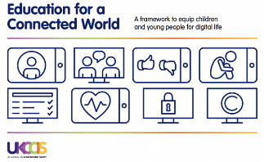  7. Privacy & Security  (6 Activities)  https://projectevolve.co.uk/toolkit/resources/years/6/privacy-and-security/ | Computer Science – Theory  6.6 Networks  (3 Lessons)  Allocate Unit 6.6 Quiz (Purple Mash) to all pupils in order to assess knowledge of the unit and skills.  Information Technology  iMovie app – Make movie trailer linked to current topic.  Select, use and combine a variety of software (including internet services) on a range of digital devices to design and create a range of programs, systems and content that accomplish given goals, including collecting, analysing, evaluating and presenting data and information.  Children make clear connections to the audience when designing and creating digital content. They are able to use criteria to evaluate the quality of digital solutions and are able to identify improvements, making some refinements.  Online Safety 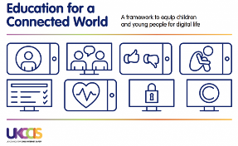  8. Copyright & Ownership  (2 Activities)  https://projectevolve.co.uk/toolkit/resources/years/6/copyright-and-ownership/

