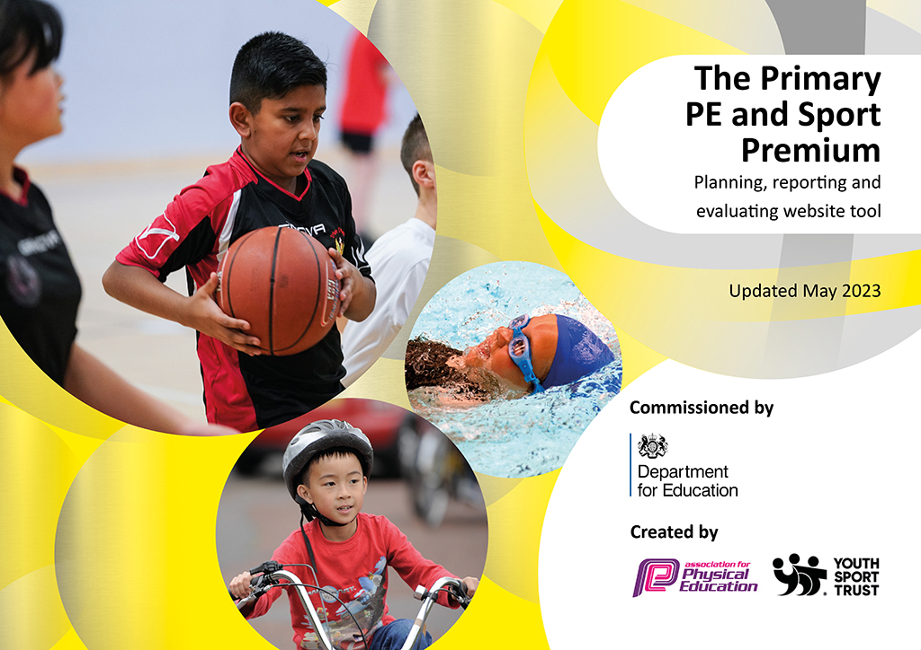
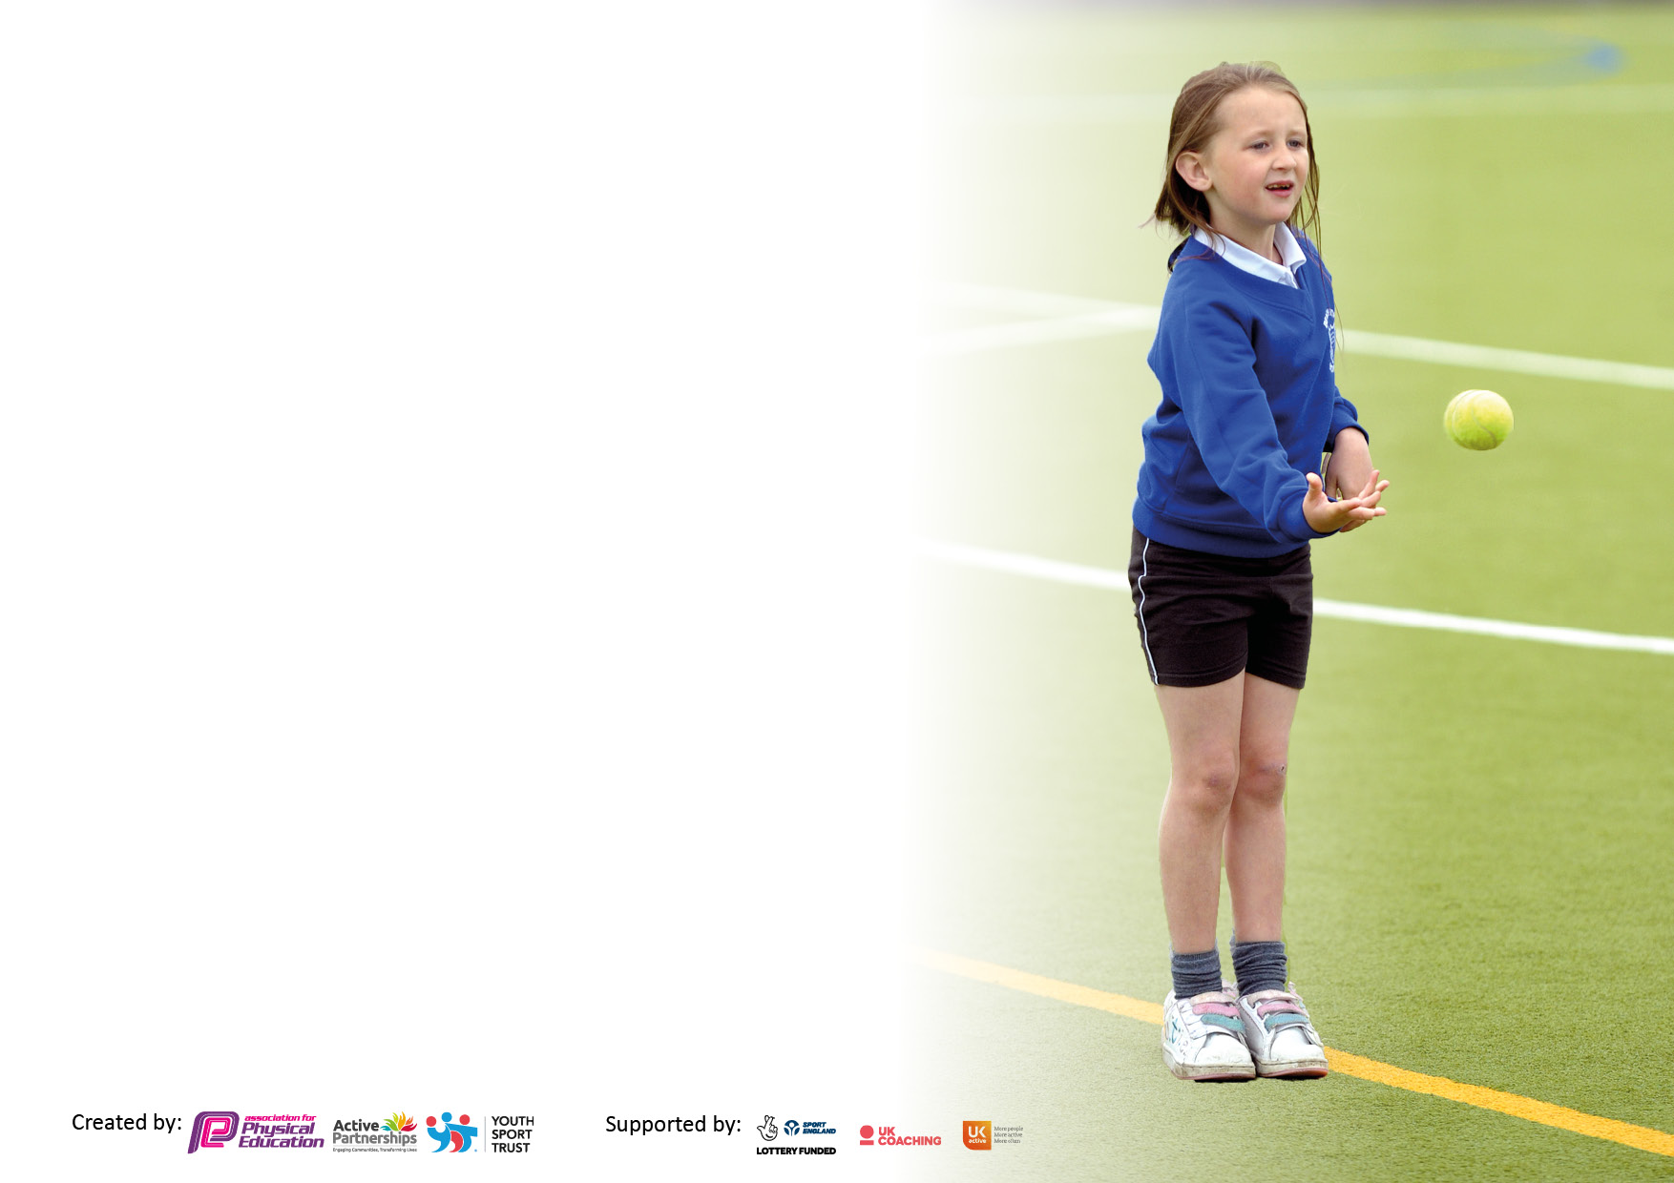

It is important that your grant is used effectively and based on school need. The Education Inspection Framework makes clear there will be a focus on ‘whether leaders and those responsible for governors all understand their respective roles and perform these in a way that enhances the effectiveness of the school’.

Under the Quality of Education Ofsted inspectors consider:
Intent - Curriculum design, coverage and appropriateness
Implementation - Curriculum delivery, Teaching (pedagogy) and Assessment
Impact - Attainment and progress

To assist schools with common transferable language this template has been developed to utilise the same three headings which should make your plans easily transferable between working documents.

Schools must use the funding to make additional and sustainable improvements to the quality of Physical Education, School Sport and Physical Activity (PESSPA) they offer. This means that you should use the Primary PE and sport premium to:

- Develop or add to the PESSPA activities that your school already offer
- Build capacity and capability within the school to ensure that improvements made now will benefit pupils joining the school in future years
- The Primary PE and sport premium should not be used to fund capital spend projects; the school’s budget should fund these.

Pleasevisitgov.ukfortherevisedDfEguidanceincludingthe5keyindicatorsacrosswhichschoolsshoulddemonstrate animprovement.Thisdocumentwillhelpyoutoreviewyourprovisionandtoreportyourspend.DfEencouragesschools to use this template as an effective way of meeting the reporting requirements of the Primary PE and Sport Premium.

We recommend you start by reflecting on the impact of current provision and reviewing the previous spend.

Schools are required to publish details of how they spend this funding, including any under-spend from 2021/2022, as well as on the impact it has on pupils’ PE and sport participation and attainment. All funding must be spent by 31st July 2023.

We recommend regularly updating the table and publishing it on your website throughout the year. This evidences your ongoing self-evaluation of how you are using the funding to secure maximum, sustainable impact. Final copy must be posted on your website by the end of the academic year and no later than the 31st July 2023. To see an example of how to complete the table please click HERE.

Details with regard to funding
Please complete the table below.

Total amount carried over from 2021/22 | £0
Total amount allocated for 2021/22 | £18,545
How much (if any) do you intend to carry over from this total fund into 2022/23? | £0
Total amount allocated for 2022/23 | £18,545
Total amount of funding for 2023/23. To be spent and reported on by 31st July 2023. | £ 18,555
Swimming Data
Please report on your Swimming Data below.

Meeting national curriculum requirements for swimming and water safety.

N.B. Complete this section to your best ability. For example you might have practised safe self-rescue techniques on dry land which you can then transfer to the pool when school swimming restarts.
Due to exceptional circumstances priority should be given to ensuring that pupils can perform safe self rescue even if they do not fully meet the first two requirements of the NC programme of study
What percentage of your current Year 6 cohort swim competently, confidently and proficiently over a distance of at least 25 metres?  N.B. Even though your pupils may swim in another year please report on their attainment on leaving primary school at the end of the summer term 2022.  Please see note above | 30.76%
What percentage of your current Year 6 cohort use a range of strokes effectively [for example, front crawl, backstroke and breaststroke]?  Please see note above | 30.76%
What percentage of your current Year 6 cohort perform safe self-rescue in different water-based situations? | 30.76%
Schools can choose to use the Primary PE and sport premium to provide additional provision for swimming but this must be for activity over and above the national curriculum requirements. Have you used it in this way? | Yes/No

Action Plan and Budget Tracking
Capture your intended annual spend against the 5 key indicators. Clarify the success criteria and evidence of impact that you intend to measure to evaluate for pupils today and for the future.

 | Academic Year: 2022/23 |  |  | Total fund allocated: |  |  | Date Updated: 7/7/23
 | Key indicator 1: The engagement of all pupils in regular physical activity – Chief Medical Officers guidelines recommend that primary school pupils undertake at least 30 minutes of physical activity a day in school |  |  |  |  |  |  |  |  | Percentage of total allocation:
 |  |  |  |  |  |  |  |  |  | %
 | Intent |  |  | Implementation |  |  |  | Impact
 | Your school focus should be clear what you want the pupils to know and be able to do and about  what they need to learn and to  consolidate through practice: |  |  | Make sure your actions to achieve are linked to your intentions: |  |  | Funding allocated: | Evidence of impact: what do pupils now know and what can they now do? What has changed?: |  | Sustainability and suggested next steps:
 | Children are active for longer periods of the school day. |  |  | Play leaders are trained to encourage younger children to participate in active playtimes and lunchtimes.  New and exciting equipment is purchased to support the active break times |  |  | £150  Play leader jackets | The children are more enthusiastic to be active for their playtimes and lunch times, which ensures that children are active for 60 minutes  per day. |  | Sustainability and suggested next steps: Each year, year 5 and 6 children are trained by the previous playground leaders to ensure that we always have good quality play leaders.
 | Children are active for longer periods of the school day. |  |  | Play leaders are trained to encourage younger children to participate in active playtimes and lunchtimes.  New and exciting equipment is purchased to support the active break times |  |  | £50  Play leader badges  £200  Play leader equipment for the playgrounds | The children are more enthusiastic to be active for their playtimes and lunch times, which ensures that children are active for 60 minutes per day. |  | Sustainability and suggested next steps: Each year, year 5 and 6 children are trained by the previous playground leaders to ensure that we always have good quality play leaders.
 | Children’s fitness levels are improved through regular exercise and challenge |  |  | The field is coned off with new heavy duty cones - daily mile is marked off |  |  | £ 360  cones | Children are very competitive and set themselves challenges to go further each time. Scores are recorded and the children compete against each other and not just their friends. Fitness levels are definitely improving and stamina levels and growing. |  | Challenges are set termly to encourage children to better their performances.  Year 5 SSOCS crew monitor the daily mile being completed.
 | Children are more enthused to be active through the day by our pedometer challenge |  |  | Moki bands – pedometers bought – whole school set  Batteries for the moki bands bought |  |  | £3,000  £100 | Children are very competitive and want to improve their own daily step challenge. Rewards are given to those with the largest counts. |  | Intra school competitions next year and a weekly leader board for all year groups placed in the gym.
 | Key indicator 2: The profile of PESSPA being raised across the school as a tool for whole school improvement |  |  |  |  |  |  |  |  | Percentage of total allocation:
 |  |  |  |  |  |  |  |  |  | %
 | Intent |  |  | Implementation |  |  |  | Impact
 | Your school focus should be clear what you want the pupils to know and be able to do and about  what they need to learn and to  consolidate through practice: |  |  | Make sure your actions to achieve are linked to your intentions: |  |  | Funding allocated: | Evidence of impact: what do pupils now know and what can they now do? What has changed?: |  | Sustainability and suggested next steps:
 |  | After school clubs . lunchtime clubs are accessible to all children. |  |  | After school clubs are free to children.  Football ( cost of football coach)whole year, 4 clubs per week  Lunchtime clubs:  Dodgeball x 3  Dance x 3  Basketball x 3  Netball x 2  Athletics x 2  T-shirts bought for the dancers to perform at the catholic partnership showcase | Funding allocated:  £5,000  £ 150 |  |  | The amount of children accessing the lunchtime and after school clubs have increased dramatically.  More children that are inactive are participating in active sports.  Children have developed skills in unusual sports.  Pupil Premium children have accessed sports clubs to encourage a healthy lifestyle.  All clubs are free to ALL children! |  | Sustainability and suggested next steps:  To train staff from within school to deliver after school clubs to children.  To continue to develop the year 5 and 6 children to support the teaching of clubs to ks1 children.  To encourage parents to pay 50% of the session cost, to allow the school to offer more ad varies clubs to all children.
 | Children are excited to learn new skills, knowledge and perform at their best, every PE lesson. |  |  | Children are awarded a sticker each lesson if they complete their learning objectives of the session or demonstrate some of the key factors asked for within the lesson. 10 stickers – the children receive a bronze level award, 20 silver level and 30 gold level.  After each session, one or two children form each class a rewarded with the star of the week PE award. This is displayed in the gym for all to see and shared with the whole school in celebration assembly |  |  | £ 300 | We are seeing huge improvements in children’s attitudes towards PE lessons.  Children are enthused and excited about the prospect of the awards.  Children are thinking more about the Learning objectives of the sessions.  We are already seeing a huge improvement in attitudes and the development of skills and knowledge.  Children thrive on seeing who the star of the week is and they are already beginning to identify the child who has received the award before it has been announced. |  | To continue to promote healthy lifestyles and celebrate childrens achievements in PE. Purchase reward charts for the coming year.
 | Children gain knowledge in all aspects of being healthy, in body, in mind and in spirit, to promote a healthy lifestyle and to support others in doing so. |  |  | Children discuss and share ideas on a weekly basis of how they can lead a healthy life and strategies that they can use to support their physical and mental health.  Recorded in floor books. |  |  | £130  A3 floor books to record | Children have great knowledge in how they can live their life following a healthy lifestyle. They can also take this knowledge and support their families to do so too.  They are more resilient and they are equipped with a range of strategies to deal with mental health and anxiety too. |  | Children will be able to talk about the physiology of sports and their body. They are able to use this knowledge in their every day lives and inform their parents of healthy living.  Continue with these sessions, develop these with the staff so all teachers and members of school staff contribute to the well being of our children and staff.

Key indicator 3: Increased confidence, knowledge and skills of all staff in teaching PE and sport |  |  |  |  |  |  |  | Percentage of total allocation:
 |  |  |  |  |  |  |  | %
Intent |  | Implementation |  |  |  | Impact
Your school focus should be clear |  | Make sure your actions to |  | Funding |  | Evidence of impact: what do |  | Sustainability and suggested
what you want the pupils to know |  | achieve are linked to your |  | allocated: |  | pupils now know and what |  | next steps:
and be able to do and about |  | intentions: |  |  |  | can they now do? What has
what they need to learn and to |  |  |  |  |  | changed?:
consolidate through practice:
To ensure children receive the best quality of teaching in all areas of PE and can develop both skills and knowledge in these areas. |  | PE lead to undertake a complete level 5 PE course |  | £200  Registration fee  £1150  Course costs  500  supply cover |  | This course has just been completed by the PE lead – the first session to disseminate the new planning assessment tools have been completed. All staff will be confident to teach all aspects of PE and they do this producing good lessons for the children.  Lessons are thorough, well planned and delivered to ensure all children can access every part of the PE curriculum. |  | Staff will supported to plan and deliver high quality PE lessons.  To continue to develop personal CPD to support our school staff.  CPD - Main focus next year.
Key indicator 4: Broader experience of a range of sports and activities offered to all pupils |  |  |  |  |  |  |  | Percentage of total allocation:
Intent |  | Implementation |  |  |  | Impact
Your school focus should be clear |  | Make sure your actions to |  | Funding |  | Evidence of impact: what do |  | Sustainability and suggested
what you want the pupils to know |  | achieve are linked to your |  | allocated: |  | pupils now know and what |  | next steps:
and be able to do and about |  | intentions: |  |  |  | can they now do? What has
what they need to learn and to |  |  |  |  |  | changed?:
consolidate through practice:
To develop gross motor skills in our youngest children whilst developing a love of activities and sports.  To encourage children to try and enjoy new activities and sports.  To develop the love of outdoor and adventurous activities |  | Little movers sessions booked for nursery and reception children – spring 1  Spring 2  Hoop starz - sessions for all of the children in school.  Jump rope for all ks1 and ks2 children and resources for ks1 to teach jump rope.  Adventure days for all year groups |  | £650  £650  £ 600  KS2 – 2,800  KS1 - £555 |  | All children actively enjoyed the sessions, so much so we booked for another half term.  The teachers saw huge benefits in the childrens behaviour, attitude to work and their developmental skills.  The children thoroughly enjoyed the sessions. They then took the skills that they had learned and used the equipment in the yard, on a daily basis.  Children’s daily active time is higher due to partaking in these sessions. |  | Sustainability and suggested  To book again for next year.  To continue to supplement childrens active experiences with a range of outside agencies.  To support each specific element of PE with a day of training from an outside club / agency.  Rugby – Falcons  Football – Newcastle united  Gymnastics – Grass roots
 | To improve skills and knowledge in swimming. |  | Top up swimming for all year 6 children |  | £560 |  | Percentage of children reaching national curriculum targets are higher than the first session. |  | Next year – years 5 and 6 will return to swimming as part of the curriculum.

Key indicator 5: Increased participation in competitive sport |  |  |  |  |  |  |  | Percentage of total allocation:
 |  |  |  |  |  |  |  | %
Intent |  | Implementation |  |  |  | Impact
Your school focus should be clear |  | Make sure your actions to |  | Funding |  | Evidence of impact: what do |  | Sustainability and suggested
what you want the pupils to know |  | achieve are linked to your |  | allocated: |  | pupils now know and what |  | next steps:
and be able to do and about |  | intentions: |  |  |  | can they now do? What has
what they need to learn and to |  |  |  |  |  | changed?:
consolidate through practice:
Children are involved in competitive inter sporting competitions  KS2 boys football  KS2 boys Football  KS2 girls football  KS 2 girls football  KS2 netball  Alnwick gardens legacy sports events for disadvantaged children  Year 4 and 6 quad kids event – competitive  Year 6 got into finals |  | Children take part in the catholic partnership cup in football –  Children are part of the netball event  Disadvantaged children take part in the Northumberland legacy event  Finals at King Edward school |  | £  Bus costs  £600  Bus cost £290  Bus £160 |  |  |  | We need more inter competetions for ks1 children  House
 | All children have the opportunity to take part in a range of competitive sports and activities across the school year. |  | We are part of the SSPP which enables all children in the school to play competitive sports over the year.  To involve all children in the Santa run. ( December)  Easer run |  | £ 500  £ 50 prizes  £50 prizes |  | All of the children showed great enthusiasm in participating in the various festivals.  Children show a higher level of competitiveness and thrive to work together as a team.  Children have become more competitive and have a real enthusiasm to win. |  | Sustainability: Children are excited to be part of competitive competitions.  Looking to holding some competitions over the next 2 years at St Wilfrids to try and encourage every child to participate in different sports. The SSOC s crew have taken onboard some of this planning for the new year.
To try and engage more children to take part in competitive sports. |  | To run lunchtime clubs which will lead to a competitive games within the sessions.  Football  Netball  Dodgeball  Bench ball  Basketball  athletics  Specific equipment bought for dodgeball |  |  |  | All children involved in lunchtime clubs have requested new and exciting clubs for the following year. Some children have joined outside school football and netball clubs. |  | School houses are now reduced to 4 houses to allows the competitive tournaments to take place 1 per half term. The SSOCs crew have created the timetable and they will help run the tournaments.

Signed off by
Head Teacher:
Date:
Subject Leader:
Date:
Governor:
Date:

